**Advanced Rod Decusping Methods for the 2D/1D Scheme in MPACT**

**BACKGROUND**

MPACT uses the 2D/1D scheme to solve the neutron transport equation for light-water reactor problems. In this scheme, the problem is decomposed into a stack of 2D planes, as shown below. This takes advantage of the fact that most of the material heterogeneity in a reactor is in the radial direction. A high-fidelity transport method can be applied in each 2D plane to capture all the complex geometry, while a faster, lower-order method can be applied in the axial direction to couple the planes. This allows MPACT to obtain 3D pin-resolved power distributions without the computational expense of performing direct 3D transport calculations on the whole core.

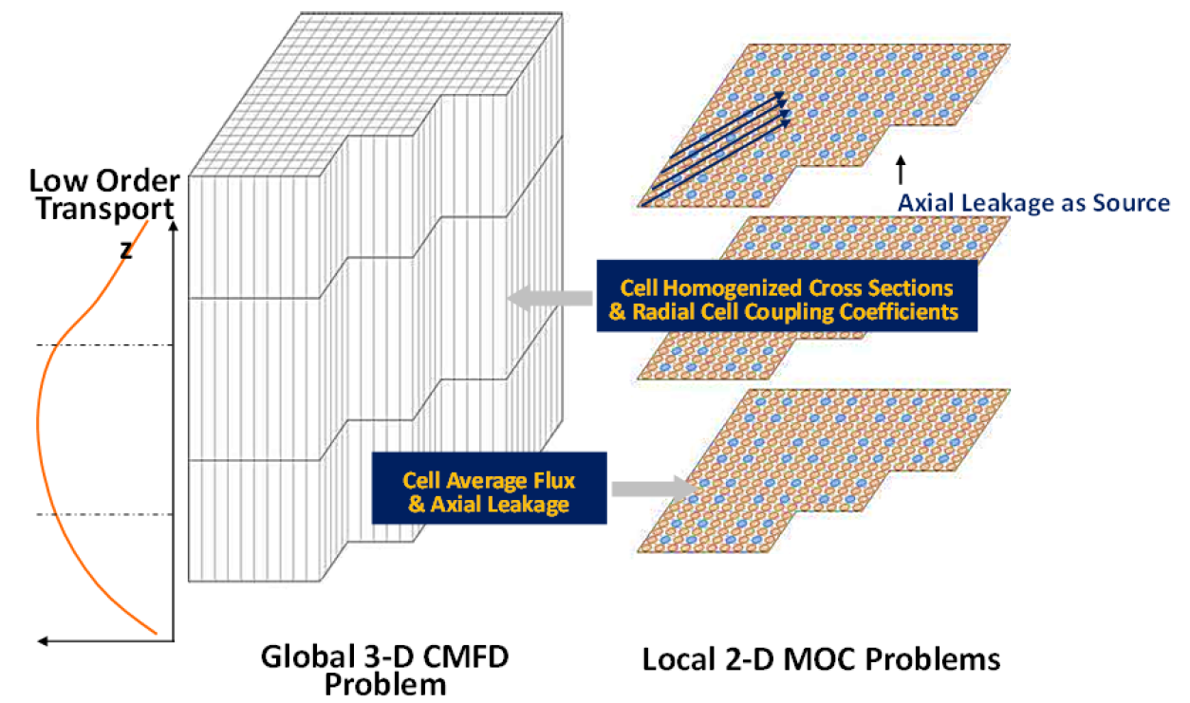

MPACT uses the 2D Method of Characteristics (MOC) in each 2D plane. MOC solves the transport equation in a characteristic direction, agnostic of geometric complexity. Applying a quadrature to the solution in each direction allows a 2D neutron flux distribution to be obtained. In the axial direction, MPACT uses the 1D SP3 method, which uses the radial leakage terms calculated by MOC as source terms. This method can efficiently calculate an accurate axial flux shape for each pin. This axial shape in turn informs the 2D MOC calculations on the following iteration.

In addition to 2D MOC and 1D SP3, MPACT uses 3D Coarse Mesh Finite Difference (CMFD) to accelerate the convergence of the 2D/1D iteration. CMFD makes the diffusion approximation to the neutron transport equation, which allows it to be written in matrix form and solved by any standard eigenvalue solver. The solution to the CMFD calculation provides an approximate 3D solution, causing the MOC calculations to converge much more quickly.

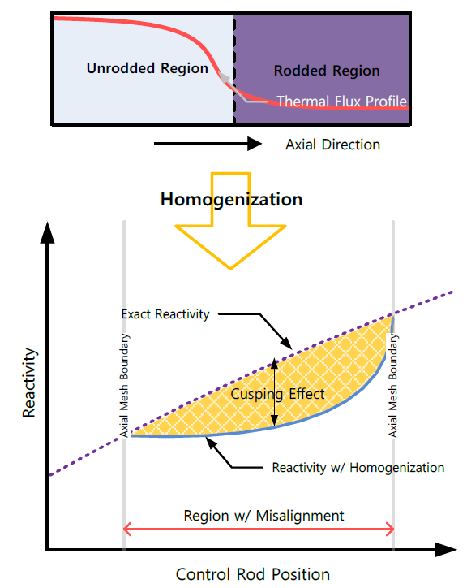**ROD CUSPING**

One problem that arises when using the 2D/1D scheme is when control rods are used. Control rods are strongly absorbing materials, and often move throughout the reactor’s operation. Because the 2D MOC calculations assume constant material properties in the axial direction for each plane, a control rod cannot be partially inserted into a plane. There are two ways to prevent this. The first is to increase the number of 2D planes and ensure that any control rods are aligned with the boundary between 2 MOC planes. The other way is to axially homogenize the control rod with the material beneath it in the plane where it is partially inserted. However, because the control rod is a strongly absorbing material, this introduces an error in the solution called “cusping,” shown on the right. The root cause of this error is that the homogenization of the two different materials only preserves the mass of each material instead of the reaction rates. Thus, absorption is artificially introduced in the bottom part of the 2D plane that does not physically have a control rod in it.

A variety of “decusping” methods have been developed to address this problem, but each of them generally falls into one of two categories: fast or general. The fast methods rely on pre-generated correction functions which change how the homogenization is done. These have generally been good enough for practical use, but any significant change in the power shape in the reactor or material in the control rod will cause these types of methods to behave poorly. Other methods perform a series of local calculations on a refined mesh at the beginning of the full-core calculation. These fine-mesh calculations are then used to inform the global full-core solution. However, doing these extra calculations up front can be expensive, especially if multiple control rod banks are in use in the model.

**NEW DECUSPING METHODS**

Recently, new methods have been developed in MPACT to address rod cusping in a more flexible manner. These methods involve improvements to the CMFD calculations to allow them to capture “sub-plane” detail within each of the MOC planes. This improves the results of the CMFD calculation. These results are then used to flux-volume homogenize the rodded/unrodded regions for the MOC calculations, as opposed to a simple volume homogenization which is normally done. This significantly improves the results obtained from the 2D MOC calculations.

While this method is an improvement on previous ones used by MPACT, it is only marginally better than methods that have been used in other codes. Moving forward, a new “sub-ray” MOC method will be developed to address partially inserted control rods and other axial heterogeneities. The goal of this method is to be able to track a ray through multiple materials simultaneously in a local region, but treat it as a single ray for the rest of the MOC plane. This will allow the partially inserted rod to be simulated as if an extra MOC plane were being used, but without the added computational burden. It is also expected that this method might be useful for capturing other reactor components, but partially inserted rods are the most important modeling difficulty to deal with.